Ministry of education and science of Ukraine
National Technical University of Ukraine
"Kyiv Polytechnic Institute named after Igor Sikorsky"
Educational and Scientific Institute
of Atomic and Thermal Energy

Department of Digital Technologies in Energy

Calculation Graphical Work
credit module:
“Methods of synthesis of virtual reality”

Done by:
Master’s student of 1-st course, ІАТЕ
group TR-42mp
Antonkin D.O.
Verified by:
Demchyshin A.A.

Kyiv– 2025
Task Description
Assignment presentation
- Share the link to your GIThub repo through this form.
- Make sure the repo contains a paper presenting your assignment
- The practical assignment has to reside in a branch named CGW.
Spatial audio
Implement spatial audio through WebAudio HTML5 API.

Requirements
- reuse the code from practical assignment #2;
- implement sound source rotation around the geometrical center of the surface patch by means of tangible interface (the surface stays still this time and the sound source moves). Reproduce your favorite song in mp3/ogg format having the spatial position of the sound source controlled by the user;
- visualize position of the sound source with a sphere;
- add a sound filter (use BiquadFilterNode interface) per variant. Add checkbox element that enables or disables the filter. Set filter parameters according to your taste.
Paperwork
Prepare a digital report that holds:
- a title page;
- a chapter describing the task (1 page);
- a chapter describing theory (2 pages);
- a chapter describing the implementation details (2 pages);
- a chapter of user's instruction with screenshots (2 pages);
- a sample of source code (2 pages).
Add report to Git branch

Variants
- 1, 8, 15, 22, 29 Фільтр високих частот

Theoretical information about spatial audio

Understanding Spatial Audio
Spatial audio refers to a set of techniques used to simulate how sound naturally occurs and is perceived in three-dimensional space. Unlike stereo sound, which confines audio to left and right channels, spatial audio creates the illusion that sound originates from specific points around the listener — in front, behind, above, or below. This type of audio enhances immersion and realism in multimedia applications, particularly in virtual reality (VR), gaming, and 3D simulations.
Human perception of sound direction is enabled by various physiological cues. These include the interaural time difference (ITD), which is the delay between a sound reaching one ear before the other; interaural level difference (ILD), which is the difference in sound pressure level reaching each ear; and the frequency filtering that occurs due to the unique shape of the listener’s head and ears. To simulate this effect digitally, systems use Head-Related Transfer Functions (HRTFs), which model how an individual perceives sounds from different spatial locations.
Several technical formats and approaches are used to implement spatial audio. Binaural audio simulates 3D sound using only two audio channels and is usually intended for headphone playback. Ambisonics is another popular approach that captures or generates a sound field in all directions, enabling flexible rendering to different speaker setups or to binaural output. Object-based audio, often used in advanced rendering systems like Dolby Atmos, treats each sound as an individual "object" with metadata describing its position and behavior in 3D space.

HTML5 and Spatial Audio
HTML5 does not natively provide spatial audio features through standard HTML tags such as <audio>, but it offers essential low-level capabilities through the Web Audio API, a powerful JavaScript API for audio processing and synthesis. The Web Audio API provides a modular audio graph system, where audio sources, effects, analyzers, and outputs can be connected together dynamically.
The core of spatial audio in the Web Audio API is the PannerNode. This node allows you to position an audio source in 3D space relative to the listener. It supports two primary spatialization models: equalpower (simple panning) and HRTF (more realistic, binaural rendering). The developer can configure the PannerNode with properties such as position, orientation, distance model (how volume attenuates with distance), and cone angles (for directional sources). This flexibility makes it possible to create highly realistic and dynamic audio environments directly in the browser.
The AudioListener object represents the virtual "ears" of the user in the 3D sound environment. Developers can modify the listener's position and orientation to match the user’s perspective, which is particularly useful in immersive or interactive applications such as virtual tours, first-person games, or VR experiences.

Integration with 3D Graphics and VR
To make full use of spatial audio, it is often integrated with visual 3D environments. Libraries like Three.js provide tools to manage 3D scenes, and can work in tandem with Web Audio API. For example, a sound source object in a Three.js scene can be linked to a PannerNode so that its audio position updates automatically as the object moves in the scene. Similarly, a user’s head position in WebXR (Web-based VR/AR) can be used to control the AudioListener’s position and orientation, keeping the audio perspective consistent with visual stimuli.
This type of audio-visual synchronization is key to delivering a convincing immersive experience. Without proper spatial audio, even high-quality 3D visuals can feel flat or disconnected. On the other hand, accurate spatial audio enhances presence and realism, making interactions feel more intuitive.

Advanced Features and Limitations
The Web Audio API also includes a ConvolverNode, which can apply impulse responses to audio signals. This is useful for simulating environments like concert halls, tunnels, or rooms — adding reverb and acoustic coloration to spatial audio sources.
However, there are limitations. Binaural rendering using HRTF is still generic — it doesn't use the specific ear shape of the listener, which means it may not work equally well for everyone. Performance can also be an issue if many audio sources and complex effects are used simultaneously, especially on mobile devices.
Another limitation is the lack of built-in support for higher-order ambisonics in the Web Audio API. Although first-order ambisonic rendering is possible using third-party libraries like Google’s Omnitone, rendering higher-order spatial precision requires more advanced tools and custom processing.

Conclusion
Spatial audio is a powerful tool for creating immersive and interactive sound experiences in modern web applications. Although HTML5 itself provides only basic media playback, the Web Audio API extends its capabilities significantly, enabling developers to simulate realistic 3D sound environments. When combined with WebGL, WebXR, or game engines like Unity via WebAssembly, spatial audio can transform how users experience web-based multimedia content.
For web developers interested in creating compelling audio-driven experiences, learning how to use spatial audio through the Web Audio API is a valuable skill. As browser performance improves and new standards emerge, we can expect web-based spatial audio to become increasingly sophisticated and widespread in use.

Implementation Details: Web Audio Integration and Spatial Sound Positioning
To enrich the user experience with spatial audio feedback, the project implements a Web Audio API-based Audio class, responsible for loading, filtering, and spatializing audio in a 3D WebGL environment. This module plays a crucial role in enhancing interactivity and immersion by linking real-time device motion data (via accelerometer) to audio spatialization.

Audio Class Design
The Audio class encapsulates the following functionality:
Initialization and Audio Context Setup
Upon instantiation, the class initializes an AudioContext—the primary interface for managing and playing audio—and a PannerNode, which enables spatialization by controlling the perceived position of sound in 3D space. The constructor accepts a file path to the desired audio file and immediately triggers loading and playback.

Audio Loading and Decoding
The fetchAudio(fileName) method uses the Fetch API to retrieve the audio file as an ArrayBuffer, which is then decoded into an AudioBuffer using audioContext.decodeAudioData. This buffer is passed to the play() method upon successful decoding.
Playback and Filtering
The play(audioBuffer) method connects the decoded buffer to the audio graph:
- A BufferSourceNode is created to stream the audio buffer.
- A high-pass BiquadFilterNode is inserted between the panner and destination to attenuate low frequencies, emphasizing directional cues.
- The listener's position and orientation are set at the origin with a forward-facing direction to simulate a first-person viewpoint.
- Audio is routed through the PannerNode, and spatialized sound is played through the system speakers.
Dynamic Positioning
The method updatePos(x, y, z) updates the panner's position in real-time, effectively changing the audio source's location in 3D space according to external sensor input.

Integration in Main Application
The Audio class is instantiated in the init() function of main.js using the line:
audio = new Audio("../media/song.mp3");
This call initializes the audio system and starts playback immediately upon application load.
To enable real-time spatial audio effects:
- A WebSocket connection receives motion data (x, y, z) from an external device (e.g., a smartphone's accelerometer).
- On every frame (via setInterval(draw, 1 / 20);), the received accelerometer values are passed to the audio.updatePos(x, y, z) method.
- As the device orientation changes, the position of the audio source is dynamically updated in 3D space, resulting in directional sound that shifts with user movement.
Additionally, the same accelerometer data is used to visually render a corresponding audio sphere in the WebGL scene, providing a synchronized visual cue to the user.
This design not only leverages the Web Audio API for immersive audio rendering but also tightly integrates it with the graphical scene and physical device input, achieving a cohesive multimodal interaction framework suitable for augmented or virtual reality applications.
User instructions
To run the application, you need to have the Git version control system installed and execute a simple command in the terminal:
git clone https://github.com/toshytwx/vr.git
Next, you need to switch to the branch in the repository where the coursework is implemented by executing the following command:
git switch -c cgw origin/cgw
After these steps, it is recommended to open the coursework project in a convenient code editor. The best option would be VSCode, as it has a sufficient number of extensions and plugins for working with code.
After opening the project in VSCode, to successfully run the program locally, you need to install the additional LiveServer plugin. This plugin encapsulates the mechanics and logic of a local HTTP server, which is done to bypass the Cross-origin policy of many modern browsers, specifically the inability to use and deploy third-party resources in web applications.
To install the plugin, go to the Extensions tab, type "LiveServer" in the search field, and install the extension as shown in the screenshot:
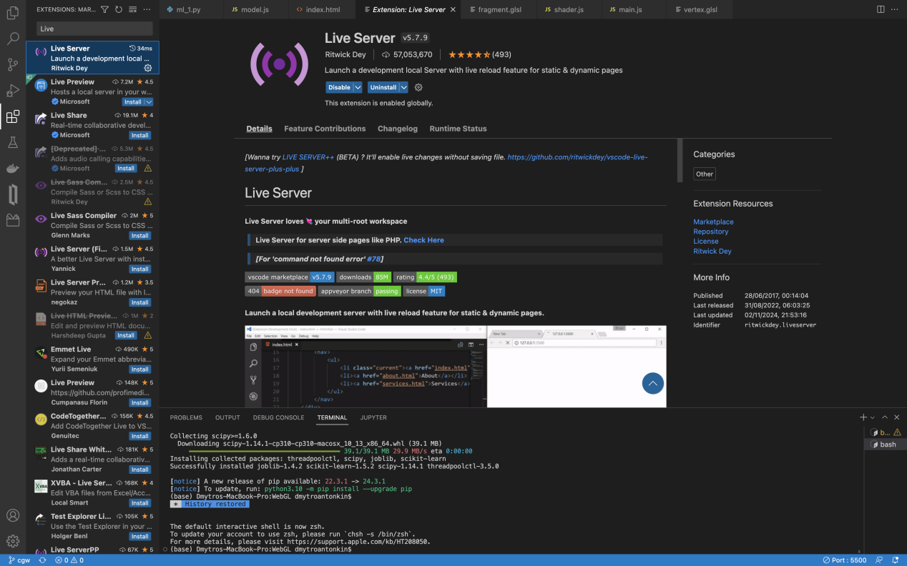
User needs to make sure that node.js installed on your machine: https://nodejs.org/en/download. Users also need to enter their local IP address in main.js line 259, they can do it via ifconfig command in their terminal, also make sure that port 8989 is not occupied by any other process. Getting back to our tangible interface - the device, this CGW developed for iPhone users specifically and application SensorLogger, which can be installed from AppStore. After short configuration of application as on screenshots below, users can start node.js server by running: node server.js command in their terminal, (note: you need to open terminal from project root folder).

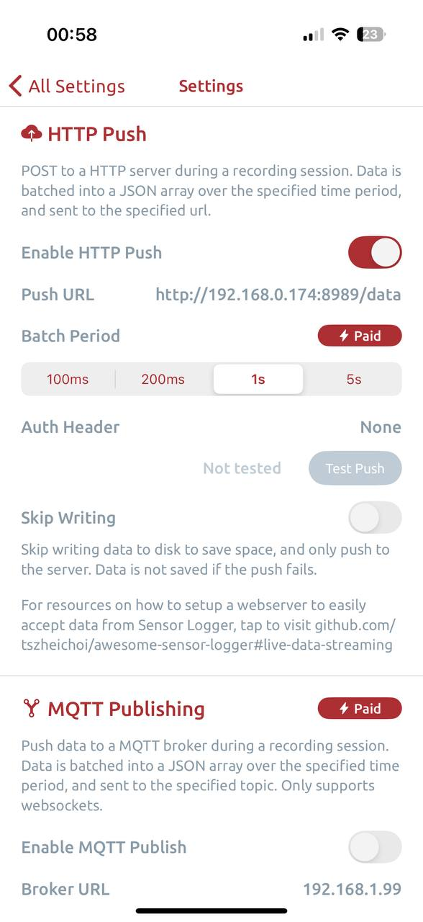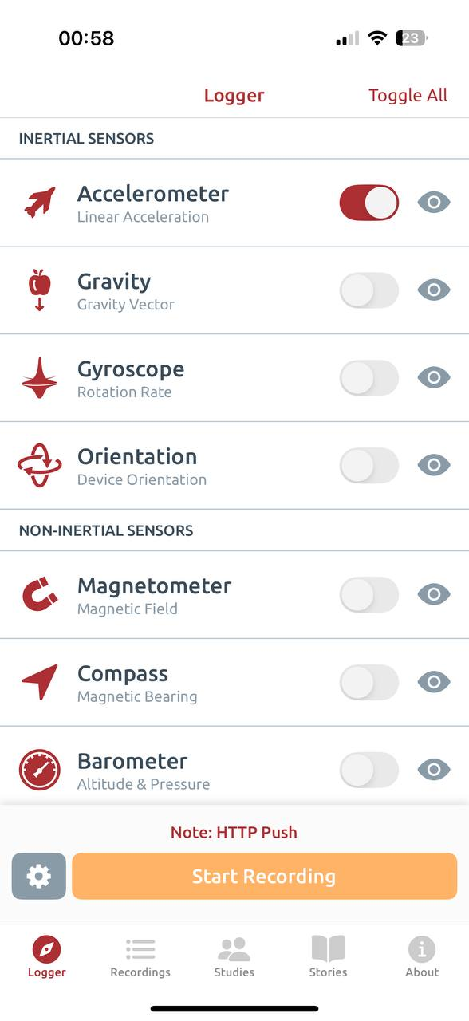
After enabling node.js server - press start recording on device to start accelerometer scalar logs in terminal. Next, users need to return to the project files, find the index.html file, right-click on it, and select the “Open with Live Server” option from the context menu. After this manipulations they should see something like this on their browser:
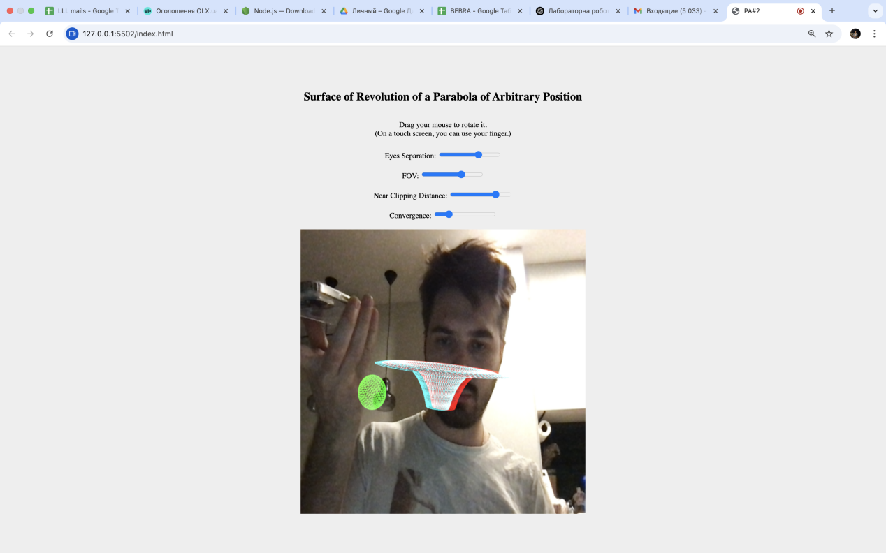
The user has the ability to change 4 frustrum parameters, thereby altering appearance of surface, namely:
- Eye separation;
- FOV angle;
- Near clipping distance;
- Convergence
Moreover don’t forget about tangible user interface - the smartphone, once you change position of it in space, accelerometer scalar will pass new scalar values to application, and it will update location of green sphere as well as location of the sound.

Code samples
class Audio {
constructor(fileName) {
this.audioContext = new AudioContext();
this.panner = this.audioContext.createPanner();
this.fileName = fileName;

this.fetchAudio(fileName);
}

fetchAudio(fileName) {
fetch(fileName).then(response => response.arrayBuffer())
.then(arrayBuffer => this.audioContext.decodeAudioData(arrayBuffer))
.then(audioBuffer => this.play(audioBuffer)).catch(error => console.error('Error loading audio file:', error));
}

play(audioBuffer) {
const src = this.audioContext.createBufferSource();
this.setFilter();

src.buffer = audioBuffer;
src.connect(this.audioContext.destination);
src.connect(this.panner);
src.start();

this.panner.connect(this.audioContext.destination);

const listener = this.audioContext.listener;
listener.setPosition(0, 0, 0);
listener.setOrientation(0, 0, -1, 0, 1, 0)
}

updatePos(x, y, z) {
this.panner.setPosition(x, y, z);
}

setFilter() {
const biquadFilter = this.audioContext.createBiquadFilter();

biquadFilter.connect(this.audioContext.destination);
biquadFilter.type = 'highpass'; // High-pass filter
this.panner.connect(biquadFilter);
}
}

export { Audio };

